VM (Scaling Options Contd)

Once we have done Resizing, we cannot do back to original state. ONLY one time we can do Resizing

If you apply resizing it is applicable to all instances

If you integrate with Azure devops then continuous delivery option will be worked

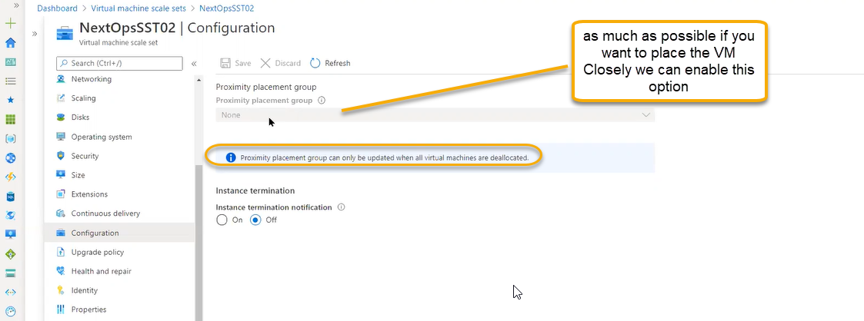

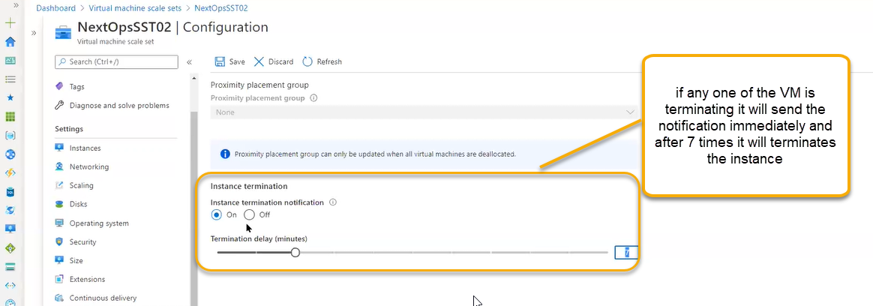

Upgrade: O.S Version change or related to feature change. Azure point of view some of the features has been added or inside running VM has end of life

After the creation of scaling and it is running and after that if some of the features has been updated

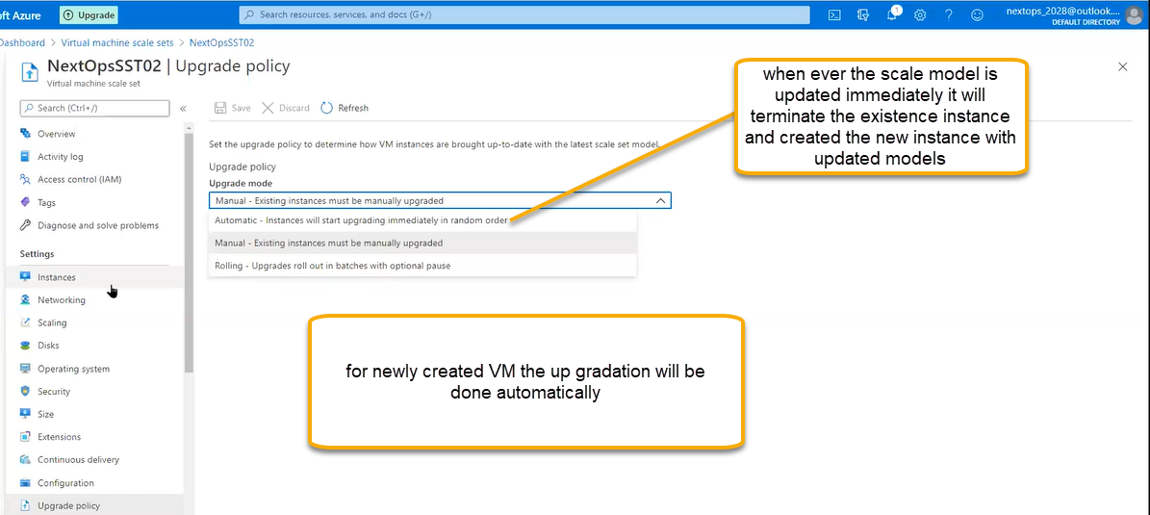

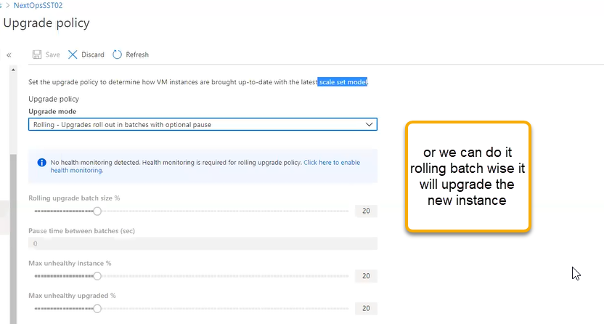

Whenever scale set, model has been updating some of the features called health and repair those will be updated, or strategies has been updated

If the instance is unhealthy and it is not UP there will two options one will be redeploy so that VM will be power off and power on the second hyper visor once VM is restored immediately it will turn into health host

Or even though it is not UP then it will create the reimage instance will be created and recreate the new image

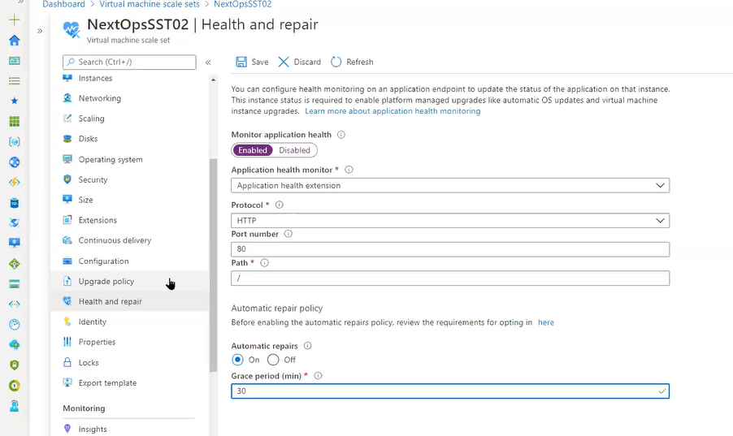

O.S Upgrade is not immediate. If 2012 running on scale set instantly we cannot change to 2016 it as long process. The application running on the scale set is important. Scale set is not configured because it should not go down every time it has to available and has to load balancer. If you do application compatibility with out checking and do O.S Updates and if the application is not compatible then we have problems

Or we can push latest image and create the new scale set

Scale identity is similar to VM level identity

Insights

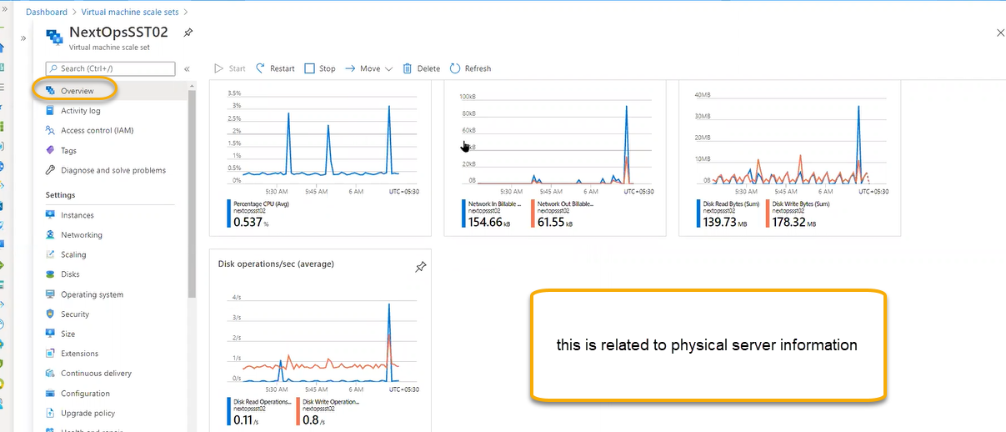

VM Level heartbeat we can see in the Insights page

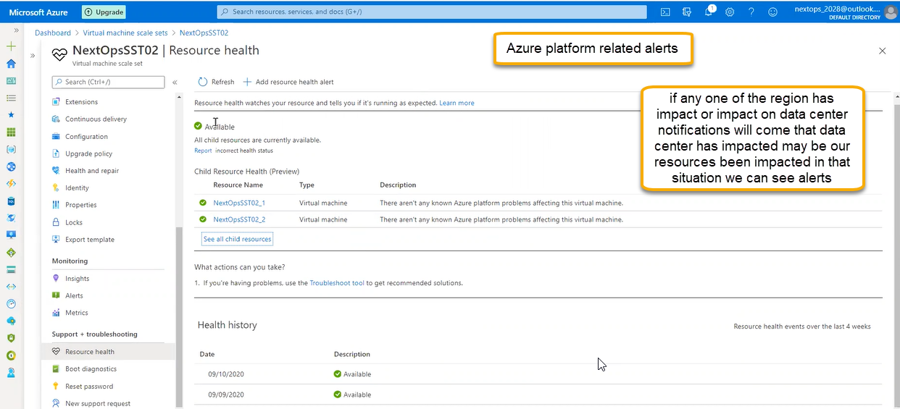

Reset password is applicable to all the instances

Currently running instances is not applicable until they are reimaged whereas it is applicable to newly created instance (password)

